**4.6 Field work and application exercise**

**Exercise materials and tasks**

**Field work and Application exercise**

This exercise covers basics of data collection and the analysis of the collected data. The exercise will also allow students to explore selected field data collection techniques. This exercise will show students how to use cloud services for quick analysis without having to download data. For data analysis purposes, we will use the Sentinel Hub platform.

This exercise consists of three parts:

1. data collection in the field,
2. an analysis of the collected data, and
3. Application report summarizing your findings.

Please familiarize yourself with the report requirements prior to starting your field work (in the next slides).

**Part 1: Fieldwork: data collection**

To collect data in the field we suggest using the SW Maps mobile app. Before any further instructions, please download SW Maps on your smart device ([SW Maps - GIS & Data Collector – Aplikacije v Googlu Play (google.com)](https://play.google.com/store/apps/details?id=np.com.softwel.swmaps&gl=US)).

The following video shows how the application is used and how you will use it to collect data <https://www.youtube.com/watch?v=bNRmrhdmujU>. You are now ready to start the fieldwork:

Individual fieldwork task:

* Please select an area close to your home. Please collect data using the SW Mapp application on your smart device.
* Using the application, please generate:
  + at least 5 reference points for 5 classes, remember that every reference point is made of coordinates (X, Y) and class name
  + one agriculture field (near your home) that consists of at least 1 acre in size (1 acre = 0.004 sq.km)
  + linear data for at least 2 classes

Note: depending on your location, define classes accordingly. For points, define classes such as lamppost, tree, parking lot… For linear classes use main street, ally, walking path, bicycle path, ….

**Part 2: Data analysis:**

After you have completed your data collection in the field, it’s time for part 2 of the exercise – the data analysis.

As shown in the video on how to use SW Maps mobile app, you need to download your collected data. Please save it on your personal computer.

Thereafter, please apply the following steps for data analysis purposes:

**Step 1:**

* Use QGIS and open a new project
* Under Data Source Manager > Vector, add exported layers (*.shp) from the downloaded data from fieldwork
* Try to use Google map or OpenStreetMap to check your data (Hint: XYZ Tiles or WMS)
* Under layers locate your agriculture polygon and right click on it > Export > Save Feature As …
* Save it as GeoJSON in the same map in which you have saved the rest of your data.

**Step 2:**

* Open Sentinel Hub’s EO browser (link: <https://apps.sentinel-hub.com/eo-browser/> )
* Click on the Create an area of interest (picture below) > Upload a file to create an area of interest

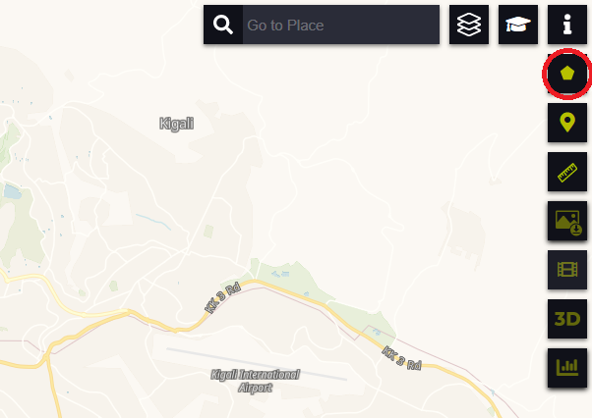

* Upload the area GeoJSON file you previously saved in Step 1

**Step 3:**

* Search for Sentinel 2 data and find NDVI index
* Calculate the statistical info (refer to the picture below) of your area of interest for the last year. While calculating NDVI or any other index, try to lower max. cloud coverage!

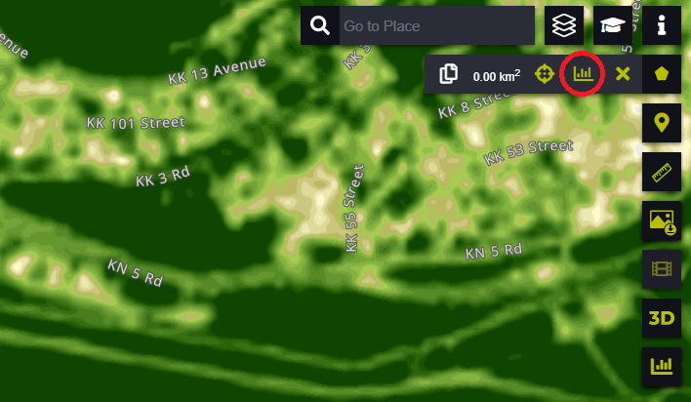

**Forum instructions**

Generate report of the application exercise and share your results in the forum

Welcome to the forum of Module 4!

As a last step, please generate a report about your findings and share your results in the dedicated forum.

The report you shall post in the forum should contain the following information:

* Make a screenshot of data in QGIS
* Make a screenshot of the statistical info for NDVI
* Provide a brief description of the selected area
* Discuss obtained results of statistical info (examples: what they represent, why we have a curve, what happens when we don’t lower max. cloud coverage, etc)
* Respond to the following questions:
  + Have you tried calculating statistical information of your area using different indices?
  + Which ones?
  + What can they tell us/show us?

Once you have finalised, please read the contributions of the other group members. Post at least one comment or question to another participant’s contribution with the idea of exchanging experiences.

Please don’t forget to answer any question you got in response to your post in the forum.

**Additional resources and material**

Before we move to the next module, we have listed below a few more resources with the aim of deepening your knowledge on the Module 4 topics. These are optional readings.

For more details (including sources of Images), please refer to the following links:

* Supervised and Unsupervised Learning in Machine Learning: <https://www.youtube.com/watch?v=kE5QZ8G_78c&ab_channel=Simplilearn>
* L. Samuel, "Some Studies in Machine Learning Using the Game of Checkers," in IBM Journal of Research and Development, vol. 3, no. 3, pp. 210-229, July 1959
* Sentinel-2 Satellite Imagery, http://geocento.com/satellite-imagery-gallery/sentinel-2/
* CORINE Land Cover - Copernicus Land Monitoring Service, <https://land.copernicus.eu/pan-european/corine-land-cover>
* <https://www.cs.huji.ac.il/~shais/UnderstandingMachineLearning/> (Understanding Machine Learning: From Theory to Algorithms c 2014 by Shai Shalev-Shwartz and Shai Ben-David Published 2014 by Cambridge University Press)

Do you want to learn more about Jupyter Notebook (JupyterLab)? Then please check out the following link:

* <https://realpython.com/jupyter-notebook-introduction/>

If you have a question about Python, it's a good idea to try the [FAQ](https://docs.python.org/3/faq/), which answers the most asked questions.

For more information about this topic, you can also listen to first 15 minutes of the following video: <https://www.youtube.com/watch?v=5NHmxYkYoZg>. For enthusiasts the whole video watch is also recommended.